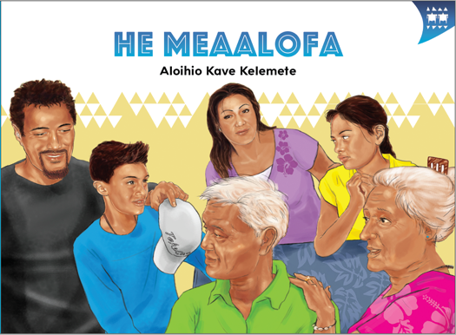
TEACHER SUPPORT MATERIALS TO ACCOMPANY:

Stories to Support the Pacific Learning Languages Series Resource
Muakiga! An Introduction to Gagana Tokelau

He Meaalofa
by Aloihio Kave Kelemete

Overview
These teacher support materials accompany the six storybooks developed especially to support the Learning Languages Series resource Muakiga! An Introduction to Gagana Tokelau. Each story gives students opportunities to extend their language and cultural knowledge and to practise reading the target language of specific units in Muakiga!
These teacher support materials suggest how teachers can use the six storybooks to foster gagana Tokelau learning at levels 1 and 2, particularly in the context of the Muakiga! programme.
The teaching-as-inquiry cycle and the Newton et al. research on intercultural communicative language teaching underpin these teacher support materials. See:
- the effective pedagogy section on page 35 of The New Zealand Curriculum
- the Newton et al.paper.

Muakiga! An Introduction to Gagana Tokelau
Muakiga! is a resource in the Learning Languages Series. It provides a language-teaching programme that can be used by teachers, including those who do not speak gagana Tokelau or know how to teach languages. Muakiga! includes:
- twenty units of three lessons each
- a range of language suitable for years 7–10 at levels 1 and 2 of the curriculum
- video and audio support to engage learners and demonstrate how fluent speakers
use the language
- lesson plans that could be linked to opportunities for learners to enjoy reading
gagana Tokelau texts.
You can find Muakiga! online here.

Engaging students with texts
The teacher’s role is to mediate the interactions between the student and the learning materials and enable the student to meet their learning outcomes.

He Meaalofa
by Aloihio Kave Kelemete
This story supports Unit 14: Gāluega (Crafts) in Muakiga!

Learning goals
Encourage your students to set one or more of the following learning goals for their work with this storybook. The learning activities support these goals.
I will use gagana Tokelau to:
- read the story and understand it
- read the story aloud with clear pronunciation and reasonable fluency
- recognise and use some words and expressions in different contexts
- write texts with macrons and correct spelling
- talk or write about the story.
I will use English to:
- understand the story when it is read aloud
- talk about the content of the written and visual texts
- give examples of how Tokelau language and culture are organised in particular ways
- make connections with the language(s) and culture(s) I know
- research and present information about Tokelau culture and values in the story
- make connections with my learning in Unit 14 of Muakiga!

Language and Cultural Knowledge strands
The Language and Cultural Knowledge strands at levels 1 and 2 of Learning Languages in
The New Zealand Curriculum require students to:
- recognise that the target language and culture are organised in particular ways
- make connections with known languages and cultures.
The language and cultural features of the written and visual texts in the storybook are described here.

(a) Language Knowledge
The language features of the written texts include:
- instructions for making a kahoa with a plaited cord and a pā (pendant), for example, Tipi kehe te ata mai te tifa. / Cut the shape from the shell.
- expressions of time, for example, Kua kuata ki te hefululua. / It’s 11.45.; Kua tā te taimi mo te kaiga o te aoauli. / It’s lunchtime now.; Io, ko au ka fanatu nei! / OK, I’m coming now!
- vocabulary for household chores, for example, Hau hāuni fakalelei tō moega. / Come and make your bed properly.; Hau fakahūhū nā lākau i mua o te fale. / Come and water the plants at the front of the house.
- words that have different meanings according to whether a macron is used or not – for example, students know the word kāiga (family) from Unit 2 of Muakiga! Now they need to distinguish kāiga from kaiga / meal
- use of different verb forms, for example, hau / come (singular) and ōmamai or ōmai / come (plural)
- words transliterated from English, for example, tīpoti / teapot (jug); henitimita / centimetre; penimāka / marker pen
- expressions of place, for example, i mua o te fale / in front of the house; ki luga o te laulau / on(to) the table; [i loto] o te fale tāvale / in the garage – but note that i loto is omitted when the reference is to people, but included when the reference is to things
- use of words that have cognates in other languages, although the precise meanings of these may differ depending on the contexts in which they are used, for example, fale (house) in gagana Tokelau, vagahau Niue, faka lea-Tonga, and gagana Sāmoa; whare in te reo Māori.

(b) Cultural Knowledge
The cultural features of the written and visual texts include:
- the value of fakaaloalo (respect). This is expressed through the dad passing his knowledge of making meatalatalai (carved objects) to his son. Peato (the dad) is the expert and teaches Teao (his son) how to make a kahoa (necklace) to give to Teao’s mum as a present. Making the kahoa includes designing and shaping the pā (pendant), and plaiting the cord that holds the pā.
- the telling of time according to the 24 hour clock and the use of the metric system for measuring. These are comparatively recent additions to agānuku Tokelau, and show how contact with other societies influences how particular concepts are expressed in a culture. Refer to Muakiga! for more information on traditional forms of measurement (Unit 17, pages 387–389) and information on other ways to tell the time (Unit 16, pages 155–158).
- the making of a gift that Teao presents to his mother. This is an expression of alofa (love), shown also in the word meaalofa (present or gift), which literally means “some love”. The kahoa is a treasured and valued gift, which is presented to loved ones, in particular, to females, at special celebrations such as twenty-first birthdays and weddings.
- the extended family living in the same house, with grandparents having a parenting role.
- the value of māopoopo (inclusion), shown in the expectation that young people help with the housework and respond when they are asked to do particular jobs.
- the significant role of the eldest girl of a family, who is known as the fatupaepae (white stone). She has authority to make important decisions, and the right to tell her siblings what to do, for example, when Hilivēlia calls Teao to fold the washing and boil the jug.

Communication strand
Students learn to apply their language and cultural knowledge in different contexts and situations to communicate effectively for a range of purposes. As they become more effective communicators, students develop the receptive skills of listening, reading, and viewing and the productive skills of speaking, writing, and presenting or performing. These are summarised on the Learning Languages Wallchart.

(a) The New Zealand Curriculum
The achievement objectives in learning languages, levels 1 and 2 are generic.
In selected linguistic and socio-cultural contexts students will:
- receive and produce information
- produce and respond to questions and requests
- show social awareness when interacting with others.

(b) Gagana Tokelau: The Tokelau Language Guidelines
These guidelines offer achievement objectives that are more specific. You could use any of the following level 2 achievement objectives to narrow the focus for your students to help them achieve particular competencies. In selected linguistic and socio-cultural contexts students will:
- understand and express concepts of amount, quality, and state (2.6)
- make requests, give instructions, and respond to requests and
instructions (2.7).

(c) Muakiga! An Introduction to Gagana Tokelau
The Unit 14 learning outcomes for students are sharply focused. The following outcomes are relevant
to this story. Students will:
- express size
- make requests and give instructions
- respond to requests and instructions
- communicate about things they have made.

Cross-curricular links
Learners who are working at levels 1 and 2 in gagana Tokelau will be working at higher curriculum levels in other learning areas. Here are two examples of cross-curricular achievement objectives that could be linked to this story when you are planning links across curriculum learning areas.

The Arts, Level 3
Students will:
- explore some art-making conventions, applying knowledge of elements and selected principles through the use of materials and processes.

Technology, Level 3 (Technological Knowledge)
Students will:
- understand the relationship between the materials used and their performance properties in technological products.

Values
The story illustrates the values of:
- community and participation for the common good
- respect for themselves and others.
See page 10 in The New Zealand Curriculum.
In addition, students will come to appreciate how the story reflects core Tokelau values of fakaaloalo (respect), māopoopo (inclusion), and vā feāloaki (relating to others). See pages 8–9 in Gagana Tokelau: The Tokelau Language Guidelines.

Effective pedagogy for language teaching
Effective pedagogy research is integrated into these teacher support materials.
The New Zealand Curriculum (pages 34–36) summarises evidence of the kinds of teaching approaches that consistently have an impact on student learning.
Research into second language acquisition pedagogy reviewed in Ellis (2005) establishes ten principles for teacher actions that promote student learning.
Research into intercultural communicative language teaching (Rivers, based on Newton et al. 2010) establishes six principles for a pedagogy that is effective in achieving the outcomes specified in The New Zealand Curriculum.

Language learning activities
Choose or adapt these learning activities to suit your students’ diverse needs and the particular objectives they are to achieve.
Listening comprehension – focus on meaning
A cloze activity challenges the students to make meaning from what they hear and reinforces their understanding of words used in particular contexts.
This activity focuses on the times that are part of the story. Hand out copies of this activity to the students. Remind them that Mum’s name is Telehia.
As you listen to the story, write in the times each person mentions.
1. “It’s ____________. Come and tidy your room,” called Telehia.
2. “It’s ____________. Come and make up your bed properly,” called Telehia.
3. “It’s ____________. Come and wash the dishes,” called Telehia.
4. “It’s ____________. Come and help me fold the clothes,” called Hilivēlia.
5. “It’s ____________. Come and put your clothes away,” called Telehia.
6. “It’s ____________. Come and water the plants at the front of the house,” called Papa.
7. “It’s ____________. Come and open up the windows in the lounge,” called Telehia.
8. “It’s ____________. Come and boil the jug,” called Hilivēlia.
9. “It’s ____________. Come with your dad. We’re going to eat,” called Telehia.

Read the story aloud, or arrange for a gagana Tokelau speaker to read it. As the students listen, they write the times in the gaps according to what they hear. You may need to repeat the reading so that your students manage to complete their entries. The students check their responses using copies of the storybooks or the English translation.

Formulaic expressions
The students recognise expressions in their contexts of use. They use some of these expressions when they communicate in gagana Tokelau in other situations.
The students work in pairs. They read the story and make a list of ten formulaic expressions they can use when they are speaking gagana Tokelau. If needed, hand out copies of the English translation of the story for them to refer to as they work on this task. Some examples of formulaic expressions are:
- Oka, te vave o te taimi nī? / Man, time flies, eh?
- Ko ni ā tā koe ē fai? / What are you doing?
- Io, ko au ka fanatu nei! / OK, I’m coming now!
- Kua uma te fai ē au. [or] Kua uma te kō faia. / I’ve done it.
Compile a list of suitable expressions, and have some students write these on charts for the classroom wall. One chart has the expressions in gagana Tokelau. Another chart has the same expressions in English. Challenge the students to use these expressions so that they communicate more in gagana Tokelau as they work on tasks in the classroom.
Link with prior learning
The students respond to requests and instructions.
Repeat the envelope activity in Lesson A on page 333 (bullet point 3) in Muakiga! to help the students recall the instructions for making a headband and review the sequence of steps.
The students draw up a list of instructions for making the kahoa. They work in pairs, taking the information from the storybook. They check their versions against the master version supplied here.
Faiga o te Kahoa
Tuhi te ata o te kahoa.
Fakaono henitimita te loa o te pā.
Tuhi te ata ki luga o te tifa.
Tipi kehe mai te ata mai te tifa.
Fakaaogā te tamā ili.
Tāofi vē.
Kikila fakalelei, nā koe e lavea.
Fakalāmolemole, nā itū o te pā i te hānipepa.
Fakaaogā vē te hānipepa.
Tago lā ki te auvili.
Tavili he tamā pū ki loto o te pā.
Vānihi te pā ke gigila.
Fakaaogā te palahi tē.
Tuku mai ki luga o te laulau ke fakamamago ai.
Fua te loa o te mea uka.
Fakafāhefulu henitimita te loa.
Fakatolu mai lā.
Nonoa nā mea uka ē tolu.
Fifili nā mea uka.
Oi huhulu ai ki loto o te pū.
Kua uma te kahoa.
Making a kahoa
The students explore some art-making conventions. They follow instructions for making a kahoa. They apply knowledge of elements and selected principles through the use of materials and processes.
Photocopy the master version for making a kahoa onto cards, and laminate these.
Arrange for your students to work in an area with the necessary materials and equipment for making a kahoa, following your school’s safety guidelines. Hand out the laminated cards. The students work on their kahoa, following the instructions in gagana Tokelau.
Patterns of language – focus on form
This activity involves a focus on how gagana Tokelau is organised in particular ways. The students adapt language when they communicate about things they have made.
The students work in pairs and describe to each other how they made their kahoa. To prepare them for this task, and to make them familiar with the language pattern to use to talk about actions in the past, repeat the activity in bullet point 3 on page 341 of Muakiga!
For an extra challenge, give them a time limit for communicating how they made their kahoa. For example, can they complete their descriptions in one minute!
Trusting their memory
This task enables the students to receive and produce information.
The students work in groups, with five students per group. They take turns to say what household chores they do. One student acts as recorder. The recorder listens carefully to what each student says, without writing anything down. When all the students have spoken, the recorder repeats what household chores each students does. All the students take turns at being the recorder.
For example, one student might say Na fufulu ē au nā ipu. / I washed the dishes.
The recorder says: Na fufulu (name of student) nā ipu. / (name of student) washed the dishes.
Crafts
The students explore, research, and present information on aspects of gāluega (crafts) mentioned in the story. They develop their understanding of the relationship between the materials used and their performance properties in technological products.
Explore the following discussion points with your students. Invite people with expertise in making Tokelau crafts to come and talk to your students and show them how particular items are made.
The students work in pairs or groups. They present their information on posters. They refer to their posters when they tell others what they found out in their research.
Possible research topics:
- The significance of pā in Tokelau culture, and the materials and designs that are commonly used.
- The tradition of carving, its importance, and the kinds of artefacts included in meatalatalai (carved objects), and their uses.
- Kinds of kahoa, their significance, and the materials used.
- Other kinds of jewellery, their significance, and the materials used to make them, for example, tautaliga (earrings).
- Gifting practices, including how gifts are presented, for example, the practice of fakakahoa – placing a pendant made with a mother-of-pearl shell lure (pā) around someone’s neck.
Reproducing text – focus on spelling
The students reproduce text with appropriate use of macrons and correct spelling.
Place several copies of the written text from page 12 on the wall (in the corridor) outside your classroom. The students are to reproduce the complete text in their workbooks in the classroom. They can make as many journeys as they like between the corridor and the classroom. They may not take writing materials outside the classroom. While this is going on, observe their behaviours, for example, how they read, walk, and write.
The students check their version against the version on page 12 of the storybook. Tell them some of the things you observed about the way they read, walked, and wrote. Enquire about their inner processes, and ask them to be precise. For example:
- Did they see the text in their mind’s eye?
- Did they hear the text in their mind’s ear?
- Did they say the text silently as they walked?
- Did they say the text aloud as they walked?
- Did their way of doing the task change throughout the activity?
These questions will open up a discussion on the processes your students used to complete the activity. Some students who found this activity difficult may find this discussion useful. They may learn some different strategies to try out next time.
Creating text – written communication
The students communicate information to another person, in writing.
The students work in pairs. Each student individually composes an email to be read by their partner. They write about something they have made. They use the written text in the storybook or information in Unit 14 of Muakiga! as a basis for their description. When they complete their communication, they send it to their partner. In this way, every student receives an email.
The students read the emails and give feedback to the writers about how well they understand the description. The feedback is to include what helped them to understand the description and what hindered their understanding.
Lead a class discussion on the kinds of feedback the students gave each other. This feedback will give you useful insights into the reading strategies and processes the students are using to develop their literacy in gagana Tokelau.

Reflecting on their learning
Help the students to reflect on their learning, and also on how they learn. Students could share these reflections with another student, with a small group of students, or with the whole class. As a prompt, ask the students questions such as:
- What strategies and activities helped you to understand the story?
- What strategies and activities helped you to remember the new language?
- How can you use the new language in other contexts?
- Can you identify aspects of new learning about agānuku Tokelau?
- How have you improved your use of gagana Tokelau?
For example, a student might say:
“I can now follow instructions in gagana Tokelau when making a kahoa consisting of a pā and plaited cord. The listening activity helped me to recall how to tell the time. I can talk about the kinds of materials commonly used for making some craft items in the Tokelau culture.”

English version of the story
In English, , this story by Aloihio Kave Kelemete is:

The Present
page 2
“Teao,” called Telehia, his mother, “it’s ten o’clock. Come and tidy your room.”
“Yeah, just a minute, OK, Mum?” replied Teao. Teao and his father, Peato, were in the garage. He was learning how to make a shell pendant for a necklace.
“Design the necklace. Make the pendant six centimetres long, OK?” said his dad.
Teao designed the necklace. The pendant was six centimetres long. “Look here, Dad. Is this OK?” asked Teao.
Peato replied, “Yeah, that’s good.”
“Teao,” called Mum, “it’s a quarter past ten. Come and make up your bed properly.”
“OK, I’m coming, Mum!” replied Teao. He picked up the shell and the felt pen.
“Draw the shape onto the shell,” said his dad.
Teao drew the shape onto the shell carefully. “Look here, Dad. Is this OK?” asked Teao.
Peato replied, “Yeah, that’s good.”
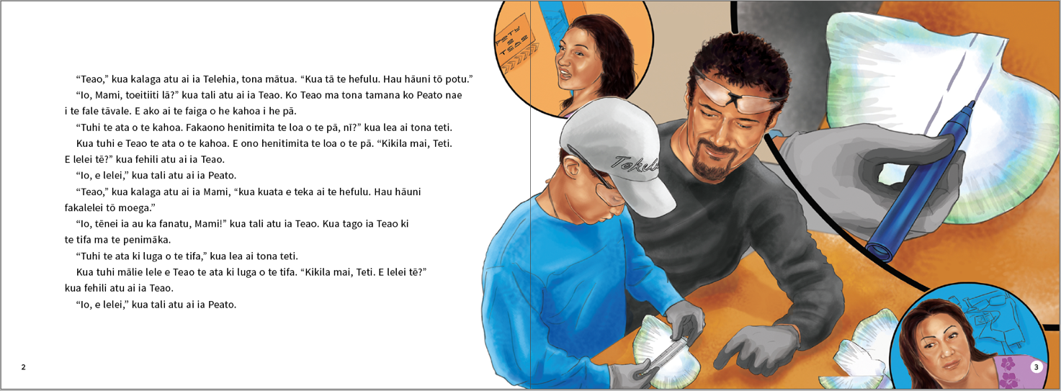
page 5
“Teao,” called Mum, “it’s half past ten. Come and wash the dishes.”
“Yep, just a minute, OK, Mum?” replied Teao.
“Cut the shape from the shell. Use the small saw,” said Peato.
Teao picked up the small saw.
“Here, hold it like this. Be careful. Watch that you don’t cut yourself,” said Peato.
Teao carefully cut out the shape. He didn’t cut himself. “Have a look, Dad. Is this OK?” asked Teao.
Peato replied, “Yeah, that’s good.”
“Teao,” called his sister, Hilivēlia, “Ii’s a quarter to eleven. Come and help me fold the clothes.”
The above page:
Text and illustration copyright © Crown
“Yep, just a minute, OK, Hilivēlia?” replied Teao.
“Smooth out the sides of the pendant with sandpaper,” said Peato. “Here, use the sandpaper like this.”
Teao smoothed out the sides with sandpaper. This part took a while. “Look here, Dad. Is this OK?” asked Teao.
Peato replied, “Yeah, that’s good.”
page 7
“Teao,” called Mum, “where are you? It’s eleven o’clock. Come and put your clothes away.”
Mum was getting impatient.
“Yep, hang on a minute, OK, Mum?” replied Teao. “What are we doing now, Dad?”
“Take the drill,” replied Peato.
Teao took the drill.
“Drill a small hole into the pendant ... like this through to the other side,” said Peato.
Teao started to drill the hole.
“Take it slowly. The pendant could break,” said Peato.
Teao carefully drilled a small hole on the side of the pendant. “I’ve done it,” said Teao.
“Good one,” replied Peato.
“Teao,” called Papa, “it’s eleven fifteen. Come and water the plants at the front of the house.”
“OK, I’m coming now!” replied Teao.
“Varnish the pendant to make it shiny. Here, use this brush,” said Peato.
Teao took the brush and began to varnish the pendant.
“When you’ve finished that, put it on the table to dry,” said Peato.
Teao varnished the pendant. He put it on the table to dry. “I’ve done it,” said Teao.
“Good one,” replied Peato.
page 8
“Teao, what are you doing? It’s after half past eleven. Come and open up the windows in the lounge,” called Telehia impatiently.
“Yep, just a minute, OK?” replied Teao.
“Measure the string. Make it 40 centimetres long. Make three of them,” said Dad.
Teao took the string, the ruler, and the scissors. He measured three lengths of string with the
ruler. He cut them with the scissors. “Look at these three lengths of string. I’ve measured them to be
40 centimetres long,” said Teao.
“That’s it,” replied Peato.
“Teao,” called Hilivēlia, “it’s a quarter to twelve. Come and boil the jug.”
“Yep, here I come!” replied Teao.
“Tie the three strings together,” said his dad. “Plait the strings together and then poke it through
the hole.”
The above page:
Text copyright © Crown
“Like this?” asked Teao.
“Yeah, just like that,” replied Peato.
Teao plaited the lengths of string carefully and threaded the plaited string through the hole.
“Look here, Dad!” he said.
page 11
“Teao,” called Mum. “It’s lunchtime now. Come with your Dad, we’re going eat. Come now!”
“Man, time flies, eh! How does it look to you, Dad?” Teao asked Peato.
“Way to go, Teao. Your necklace looks great,” replied his dad proudly. “Come on, let’s go inside
and eat.”
“Teao,” asked Mum. “What were you doing out the back? I was calling out for you a lot! I was calling you to come and do your chores!”
“Yeah, I was calling you to come and help me fold the clothes and to boil the jug,” said Hilivēlia.
“Yes, I was calling you to come and water the plants at the front of the house,” said Papa.
“I was calling you to come and open the windows in the lounge. So tell me, what were you two
doing in the garage?” asked Mum.
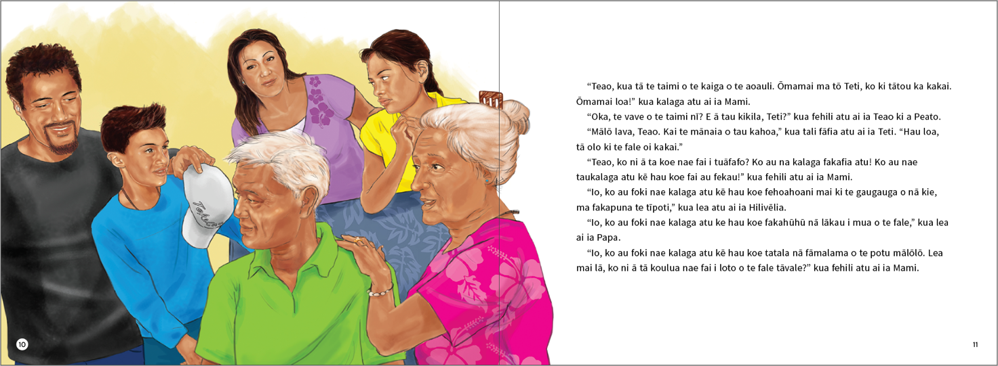
page 12
Teao replied, “I was making you a present.” He showed his mum the necklace.
She was very surprised when she saw the necklace. “Teao, thank you so much! It’s pretty!” she said.
Teao placed the necklace around his mum’s neck.
“Thank you, Teao,” said Telehia, “but when you’ve finished lunch, go and do your chores, eh?”
Dad just laughed.

ISBN 978-1-77669-702-1 (WORD)
ISBN 978-1-77669-703-8 (PDF)
The above page:
Text and illustration copyright © Crown

Newton, J., Yates, E., Shearn, S., and Nowitzki, W. (2009). Intercultural Communicative Language Teaching: Implications for Effective Teaching and Learning. Wellington: Ministry of Education.

